Prerequisites

IBMcloudservice

Step-1

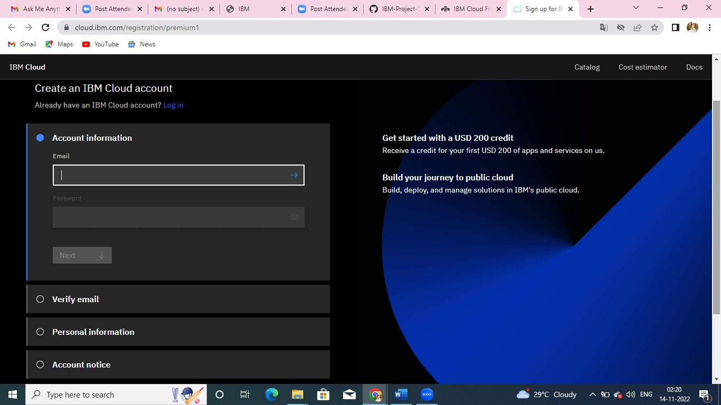CreateIBMAccount.

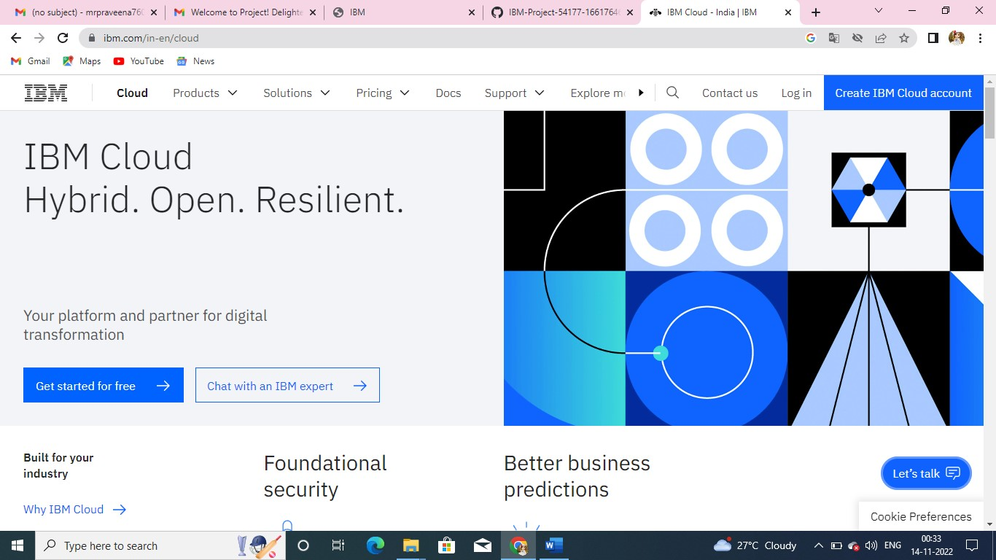

Step-2

CreateIBMCloudAccountWithEmail Step3: LogintoIBMCloud

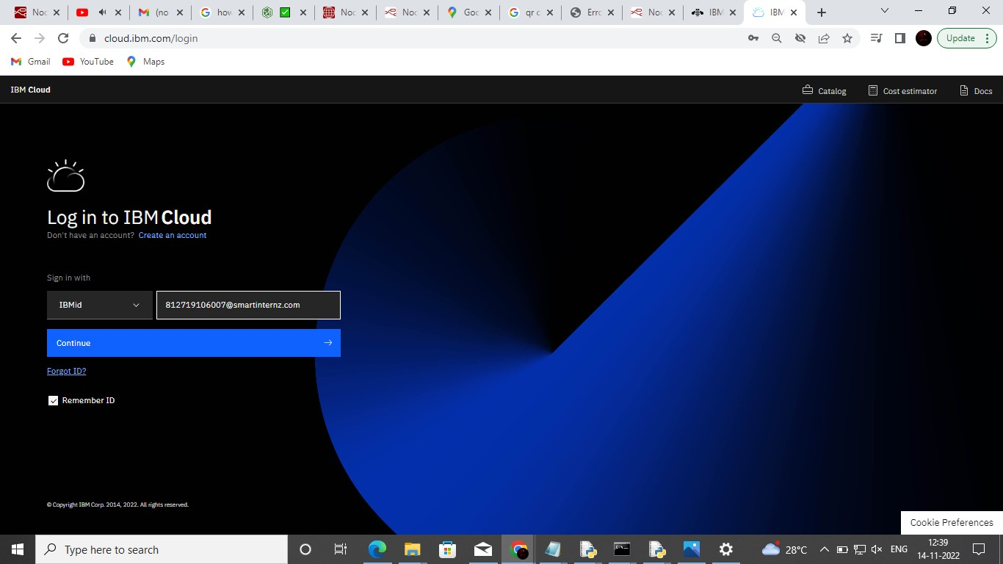

Step-3:

Password

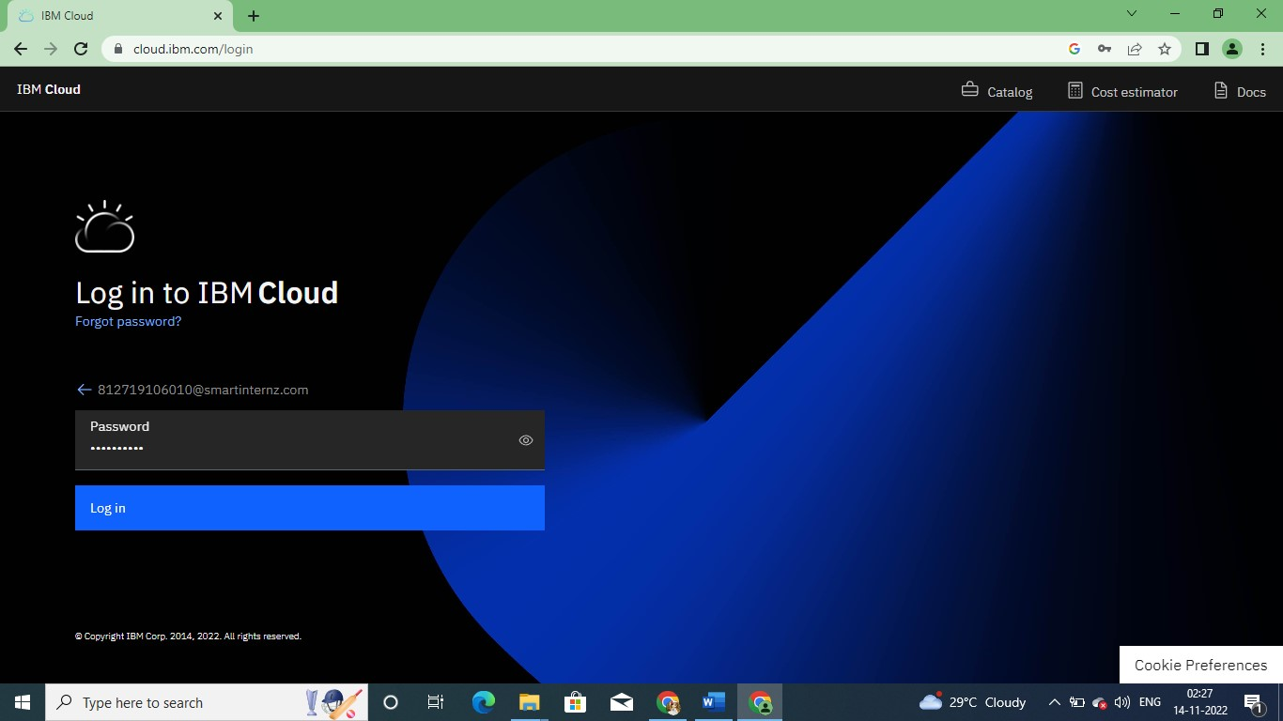

Step-4

OncelogintoIBMcloudAccountwegettheIBMcloudDashboard

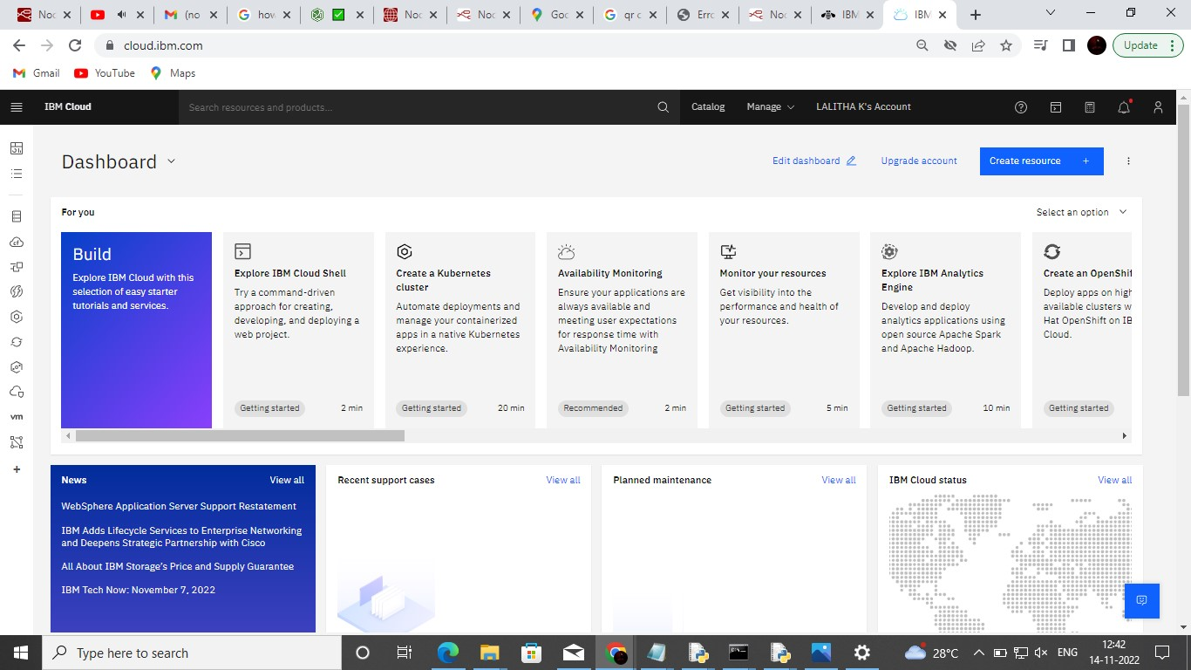

Step-5

•IBMWatsonIOTPlatform

•Node-REDService

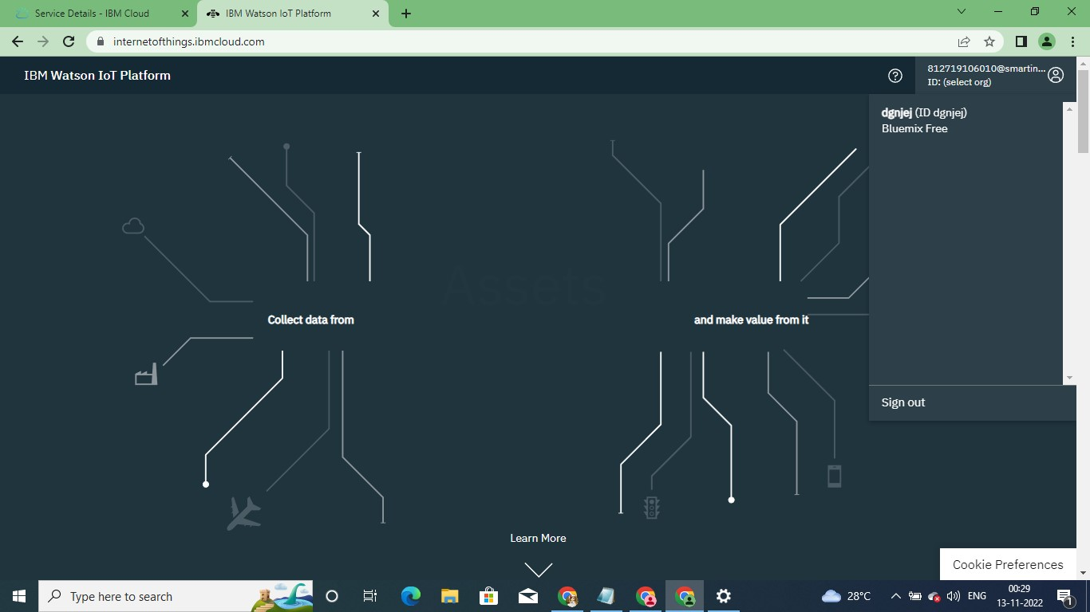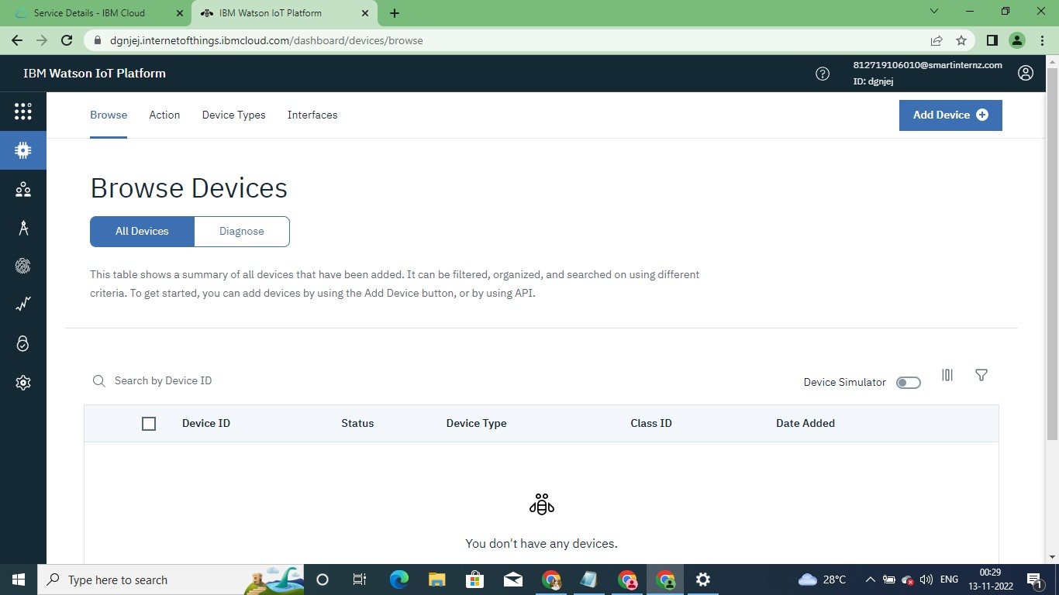

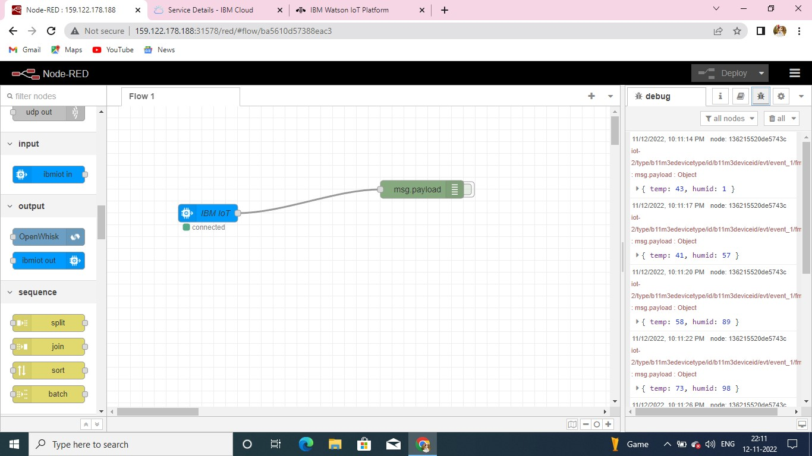

Step-6 CloudantDB

